# 

# 

# Product Requirements Document Template

## Objective

* Who is this solution for? Anyone vulnerable to attack
* Which problem are we attempting to solve? Walking alone at night (or anytime) is dangerous
* What is the purpose of this product or feature? To discourage predators from attacking the user
* What will it do, what will it not do in the scope of this iteration? Have the screen and sound make it appear that there’s someone on the phone talking with the user; make a loud, warning sound when desired, can also activate a bright flashlight; see below for later versions
* What is the product vision? later versions will have more interactivity, such as ability to contact police or another source of help; GPS; ability to detect motion, and sudden, unexpected changes in speed and direction; ability to note dangerous areas for other travellers

## Research

* User research
  + Stories, interviews, focus groups (*if any at this stage*) - people who have been attacked or narrowly escaped
  + User personas (*detailed version of “Who is this solution for?”*) - anyone who is vulnerable -

1. Sue works late and walks home afterward, part of her walk is in a dangerous neighborhood
2. Mike is a BIPOC teen who has to walk through a traditionally “good” (if you’re white) neighborhood
3. Kyra has to walk through a gang area
4. Sara is waiting for her friend (who is late) and has to hang out on a corner until the friend gets there

* Market assessment
  + What is our target market? Anyone who is not The Rock
  + Where would we want to launch first? New York City
  + Who are our competitors? [bSafe, My safetipin, Life 360, Noonlight](https://www.makeuseof.com/tag/best-apps-safe-walking-alone/)
* Stakeholders and funding
  + Who do we need to reach out to? The government,
  + Who have we already connected with? No one
  + What internal team is working on the project? Kalevtutar, Jesoul, Andrea
  + How can we fund it? We might consider reaching out to this organization called AnnieCannons

## Core Product Components (*or feature components if feature*)

* What are the core features in the first iteration?
  + What does the product “do”? Core features - to appear that the user is talking with someone friendly and who would be capable of getting help if needed, and who is monitoring the situation; the product’s skateboard version design is to prompt possible attackers to reject the idea of attacking the user, as the likelihood of getting away successfully would be very low
  + What actions do we want the user to complete? the user would need to open the app, have fine GPS location on their phone (for later versions); also there should be a checked advisory that predators often look for distracted people to attack, so while using the app, it is best to keep fully aware of your surroundings and to have minimal input on user’s side of the phone “conversation”

## User Flow (*or process flow if not product*)

* Walkthrough of core user actions and functional requirements 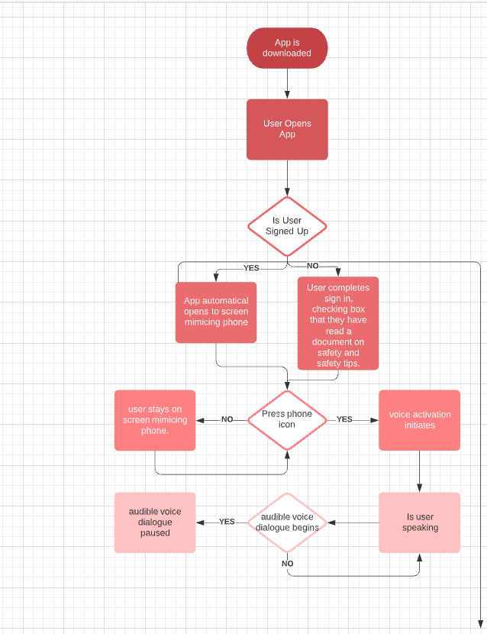 no sign-in for first and basic version - later versions with things like options to call other than 911 would require some sort of way to identify the user - biometrics a good use here; first version (and base version) voice going, screen appears to be a call; to end, close the app or press “arrived”
* Wireframes (*if applicable*) *-* first version (and base version) would have an opening screen, then the screen during the app functioning would mimic that of an ongoing call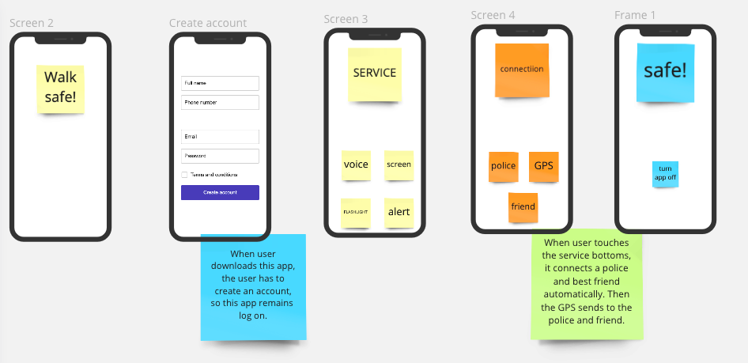
* Sitemap (*if applicable*) - only for later versions, in order to set up preferences, e.g. to have the app call someone other than 911, or to record dangerous areas for future travelers (similar to Waze)

## Specific Requirements

* Release Requirements
  + Functionality — Is there a baseline percentage of the original features that must be retained? What are the absolute mandatory functions? - has to show the screen and have an audible voice coming from the phone
  + Usability — Is the program aesthetically striking and intuitive to users? It will be as basic as possible. What is the acceptable time to complete tasks for each use case? Super fast
  + Reliability — What’s the maximum acceptable failure rate? Are these failures predictable? Can the system recover from these failures? As failure can mean someone dies, failures must be kept to a minimum - zero. As for technical failures, if the app crashes, we would like it to appear that the phone connection was lost, and restarting the app will appear as calling back the person (as if they’re on speed dial)
  + Performance — How fast must it be? What is the maximum response time, throughput, and memory consumption? The base version is very simple and should take minimal time and memory
  + Supportability — Is it testable, serviceable, installable, and configurable? It will be easily testable (although the ability in later versions to dial 911 will have to be carefully tested as we don’t want to actually bother 911 for testing
* Technical Requirements (i.e. as related to Security, Data, Network, Platform, Integration)
  + What engineering expertise will we need? Code developer, UX-Designer, interacter manager, product manager.
  + What core landing pages/elements/properties will the product have? Base version will appear to be an ongoing phone call
  + Are there specific integrations that are important? Later versions will have the app auto-dial various numbers, record GPS, speed, direction, have loud sounds and bright flashlight, and crowd info on dangerous areas
  + Special security considerations? Keeping the outgoing audio either indistinct enough, or varied enough that predators can’t learn what is a real conversation as opposed to this app
  + Data analysis needs? Later versions will need to know things such as location, speed, direction and a crowd-sourced map of areas to be extra cautious of
  + Logging or record keeping needs? Later versions will have the ability to call a preferred number other than 911, GPS, speed and direction tracking, and crowd-sourced map of dangerous areas
  + Data deletion needs? Ability to erase the optional help number(s) and tracking

## 

## 

## 

## 

## 

## Timeline and Milestones

Note: This chart has only current activities for now, as we don’t know enough of the process and how long things take, to fill it out properly

| Milestone | Key Activities | Owner | Start Date | Due Date |
| --- | --- | --- | --- | --- |
| User flow | Design flow | Andrea | 06/08/21 | 06/10/21 |
| Wireframe | Design wireframe | Jesoul | 06/08/21 | 06/10/21 |
| PRD | PRD write-up | Kalevtutar | 06/08/21 | 06/10/21 |
| Research | Research | All three | 06/08/21 | 06/10/21 |
| Solving issues | Resolving issues brought up in meeting | All three | 06/08/21 | 06/10/21 |

## Constraints & Risks

* What are the biggest risks to meeting the above milestones? Having no idea how to build this
* What are our constraints?
  + Time? While sooner is better than later, there is no specific rush for this
  + Resources? As a group of three, we don’t have the money to build this
  + Expertise? We don’t know how to do any of this yet
  + Connections? I think we might have an “in” at AnnieCannons...

Measuring Success

* How will we measure our success? First version successes would be people downloading the app and reporting satisfaction with it; later versions would look at successful calls for help being made through the app; generally, success would be the safety of the users; good feedback from the user with ratings
* What key goals and milestones are we working towards? Greater safety
* What impact do we want to see in 1 year? 2 years? 3 years? A general decision on the part of perpetrators that it’s best to leave people alone

Future Iterations

* What additional features do we think we want to implement in later phases of the product?

| Feature | Description | Time to Implementation |
| --- | --- | --- |
| Location detection | Fine GPS | Second version |
| Call for assistance | Call 911 or other | Second version |
| Speed and direction detection | Check for sudden, unexpected changes | Third version |